**NAME: Syed Aoun Haider (23L-2595), Uzair Mujtaba (23L-0864)**

**PF-Project “Candy Crush”**

**Libraries:**

* iostream
* SFML/Graphics.hpp
* SFML/System/Clock.hpp
* fstream
* cstdlib
* ctime

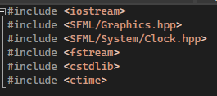

**Global Variables:**

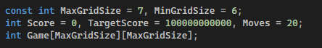

**Function 10 (main):**

* First asks the user the size of the game (GridSize) and checks whether the input is within the limit.
* Asks user to enter “1” to play saved game or “0” to start new game.

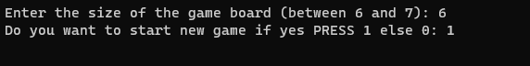

* Plays the game in fullscreen mode with “score”, “moves” and “timer” on the left and grid in the middle.
* Set textures, size, positions of candies and background.
* Display candies, save button, score and time.

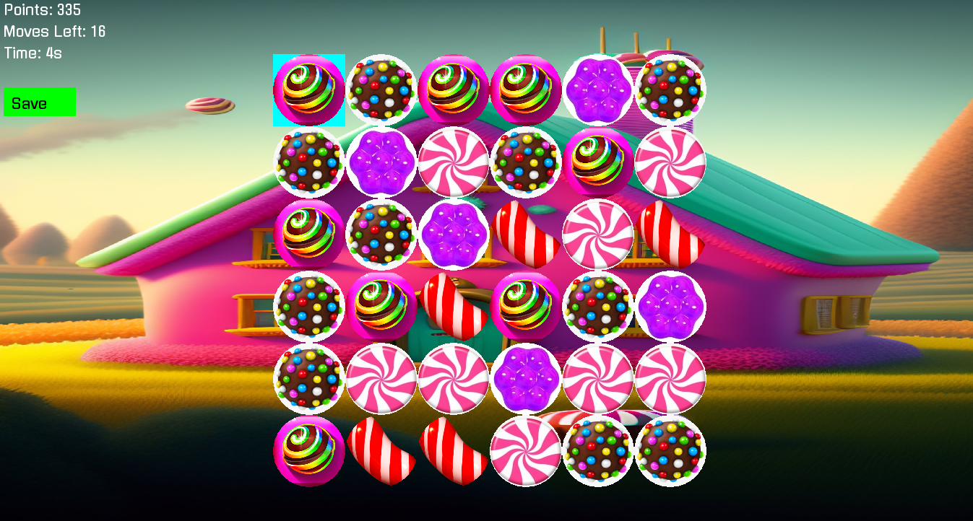

* If time is elapsed and there is no move, it restarts the timer and decrements the moves.
* If candy is moved, it restarts the timer and decrements the moves.

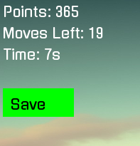

* Checks if either the number of moves are finished or score is above the target score it closes the window (i.e. game).
* It highlights the gridsection being selected in “Cyan” colour by using left mouse key.
* It swaps the candy by arrow keys of keyboard.

**Function 1 (WinCheck):**

If the target score is acheived, it closes the game.

C:\Users\Lenovo\OneDrive\Pictures\Screenshots\Screenshot 2023-12-08 073709.png

**Function 2 (FailCheck):**

If the target score is acheived, it closes the game.

C:\Users\Lenovo\OneDrive\Pictures\Screenshots\Screenshot 2023-12-08 073738.png

**Function 3 (DeallocateGame):**

Clears the game.

**Function 4 (Select):**

Highlights the gridsection being selected in “Cyan” colour by using left mouse key.



**Function 5 (SwapCandies):**

It swaps the candies being moved by the arrow keys of the keyboard.

**Function 6 (CheckMatches):**

* It check the matches for elbow, 5, 4 and 3 in horizontal, vertical and diagonal direction.
* If there are matches, it increases the score and set the pop up candies to 0.

**Function 7 (FillGrid):**

It fills the grid with random numbers between 1 and 5 which are further set textured as candies in main function.

**Function 8 (SaveGame):**

It saves the current game when save button is pressed and displays the message on console.



**Function 9 (LoadGame):**

It loads the game from the folder (if any) and plays the saved game on the screen.